**QSMART – TEMP SENSOR ASSY REPLACEMENT**

**PROCEDURE**

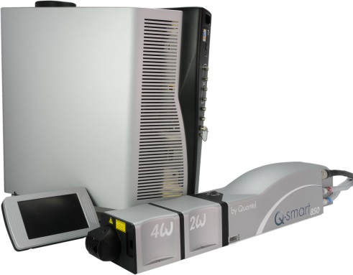

**Toolkit:**

Allen keys

**System**: QSMART

|  |  |  |  |  |  |  |  |  |
| --- | --- | --- | --- | --- | --- | --- | --- | --- |
| |  |  |  |  |  |  |  | | --- | --- | --- | --- | --- | --- | --- | | |  |  | | --- | --- | | **SM010350** | **Q-SMART TEMP SENSOR ASSY** | |  |  |  |  | |  |

**Purpose**: This document details how to change and adjust the laser head temperature sensor

|  |  |  |
| --- | --- | --- |
| Revision | date | modification |
| Initial issue | July 4, 2014 |  |
|  |  |  |
|  |  |  |
|  |  |  |

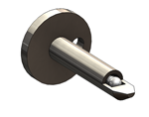

# DISASSEMBLING OF THE SENSOR

* Turn the system off
* Disconnect cables and water hoses from the side of the laser head
* Remove the laser head cover.
* Remove the side plate (7 BHC 3x6)

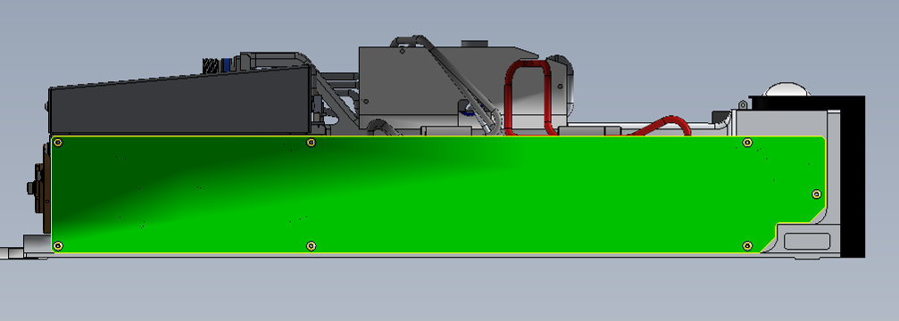



* 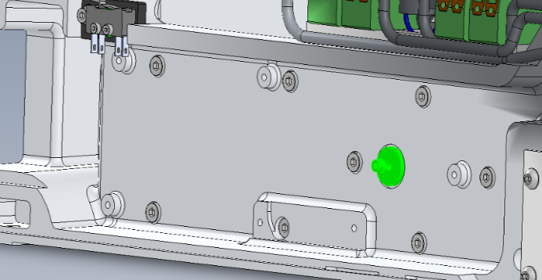Unscrew (CHC 2.5x6) and remove the sensor support (3/MEC/4929)
* Unscrew the screws holding the LB card (5 screws CHC3X6).

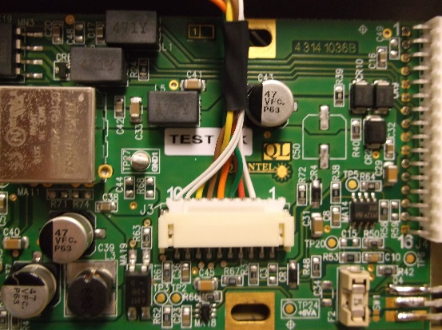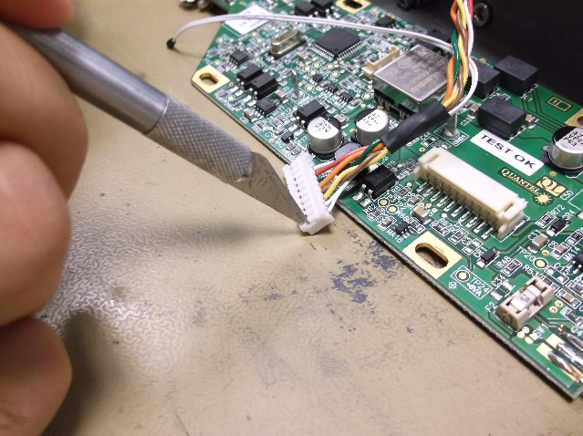

Remove the 2 sensor wires

* Remove the sensor wires from the connector
* Cut the tape and remove the sensor (support + sensor + wires)

# IMPLEMENTATION OF SENSOR

|  |  |  |
| --- | --- | --- |
| 1.00 | V/CHC-M2506A4 | CHC2.5X6 SCREW |
| 5.00 | V/CHC-M0310A4 | CHC3X6 SCREW |
| 4.00 | R-MU--D03--A2 | MU3 WASHER |





* Insert the sensor wires in the connector like shown (2 last pins) and plug back all connectors on the card.
* 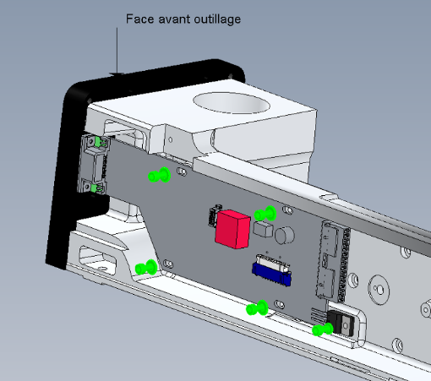Link between them the wires using adhesive tape.
* Pass the cables under the LB card 4/300/1036.
* Fasten with 5 screws CHC 3x6 + 4 washers

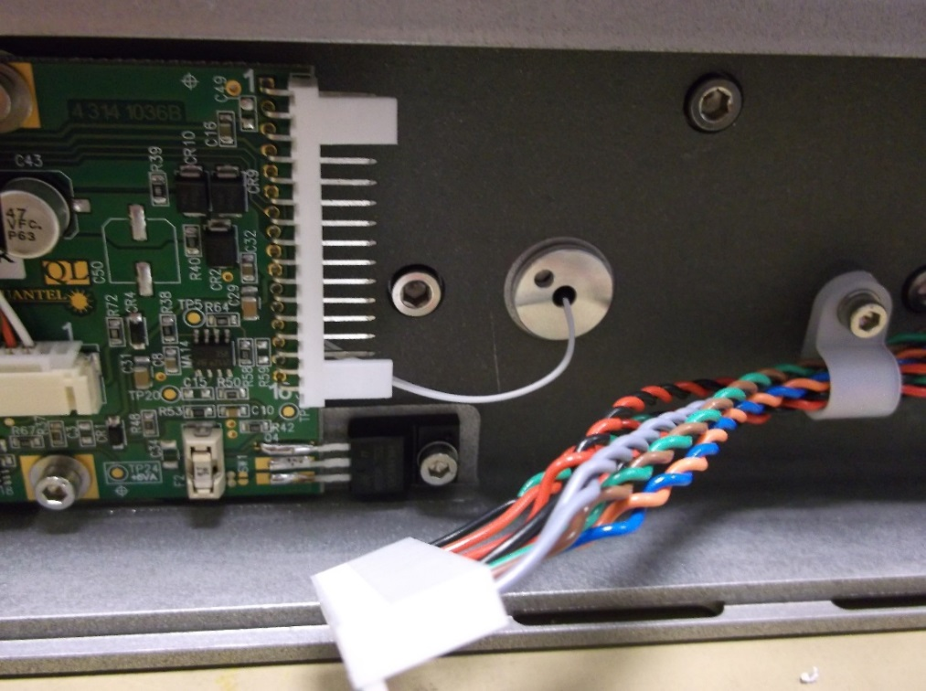

* Fasten the sensor SM010350 and its support with a CHC 2.5x6 screw.
* Reinstall the side plate and the laser head cover
* Close the Laser head and put warranty stickers   
  *Refer to "LH-Warranty Labels"*